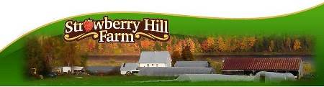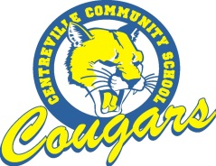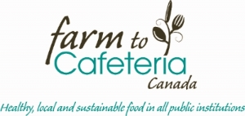
“Farm to School” Farm Fresh Menu
Starting Tuesday, September 22
Served in the Cafeteria at lunch time ,Tuesday , Wednesday & Thursday
Same Day Purchase or Pre Order Specials
Pilot project to offer local, fresh, salads and soups to CCS students & staff
Soup:
Chicken vegetable & Roll/ Crackers
Hamburger Vegetable & Roll/ Crackers
Salad Bar Items
Lettuce, Tomatoes, Cucumbers, Red Onion, Celery, Grated Carrot, Carrot sticks
Hard Boiled Egg or Cheese; WW Roll; Salad Dressing

Pre Order Specials:
3 soup or full course salads : 7.50 3 Soup & Salad: $12.00
Purchase 10 soup or full course salads: 22.50 Get next two free
Purchase 10 soup & salad combo- $40.00 Get next two free
Side salad or small dish with one veggie from salad bar of student choice: 10 for $10.00 with next two free
Purchase daily at salad bar:
Soup & Roll: $2.50
Main Course Salad & Roll: $2.50
Side Salad or 1 Veggie in small dish: $1.00
Extra Roll: 25cents

